

PROJECT REPORT

CSE303: DATABASE MANAGEMENT

**STUDENT PERFORMANCE MANAGEMENT SYSTEM**

**Table of Contents**

TEAM: THE PROCRASTINATORS 8

CH-1 INTRODUCTION 9

**A. BACKGROUND OF THE ORGANIZATION** 9

**B. BACKGROUND OF THE PROJECT** 9

**C. OBJECTIVES OF THE PROJECT** 10

**D. SCOPE OF THE PROJECT** 10

CH-2: REQUIREMENT ANALYSIS 11

**A. DESCRIBE EXISTING BUSINESS SYSTEM (WITH RICH PICTURE)** 11

**B. PROCESSES ALONG WITH SIX SYSTEM ELEMENTS** 12

**C. PROCESS DIAGRAM (AS IS)** 23

23

**D. EXISTING PROBLEMS & ANALYSIS OF THE PROBLEM** 26

**E. DESCRIBE PROPOSED BUSINESS SYSTEM (WITH RICH PICTURE)** 29

**F. PROPOSED PROCESSES ALONG WITH SIX SYSTEM ELEMENTS.** 30

**G. PROCESS DIAGRAM (TO BE)** 36

37

38

CH-3 LOGICAL SYSTEM DESIGN 39

**A. BUSINESS RULES** 39

**B. ERD** 41

**C. ERD TO RELATIONS** 42

**D. NORMALIZATION** 43

**E. DATA DICTIONARY** 49

CH-4 PHYSICAL SYSTEM DESIGN 54

**A. INPUT FORMS, OUTPUT QUERY & REPORTS** 54

**O PURPOSE** 54

**O CONTROLS AND FLOW CONTROLS OF THE FORM** 54

56

**O RELATED SQL USED** 62

CH-5 CONCLUSION 67

**PROBLEM & SOLUTION** 67

**ADDITIONAL FEATURE & FUTURE DEVELOPMENT** 67

**CONCLUSION & RECOMMENDATIONS** 67

# TEAM: THE PROCRASTINATORS

|  |  |
| --- | --- |
| **ID** | **NAME** |
| **1820735** | **Imam Tajnoor Hossain Amrit** |
| **1830022** | **Nahiyan Ibn Ershad** |
| **1911041** | **Joyita Faruk** |
| **1821503** | **Ananya Chakraborty Gourab** |
| **1910343** | **Jahedul Islam** |
| **1830968** | **Md. Yakub Hossain** |

# CH-1 INTRODUCTION

## **A. BACKGROUND OF THE ORGANIZATION**

Independent University, Bangladesh (IUB), one of the leading private institutions in Bangladesh, was founded in 1993 and places a clear emphasis on research and international collaborations. With over 9800 undergraduate and graduate students, over 13,700 alumni, and more than 450 highly skilled faculty members, 47% of whom hold PhDs, they are a full-service, exceptional university. The number of students is expected to increase by 10% a year. The three academic semesters at IUB are spring, summer, and fall. Two months before the start of each term, admission tests are held in November, April, and July. The objectives of IUB are to produce graduates of international standards in the local setting, equipped with the knowledge and necessary abilities to exercise leadership in business, government, and welfare; to encourage and support fruitful research; to generate knowledge; and to offer opportunities for adult learners to continue their education.

## **B. BACKGROUND OF THE PROJECT**

The goal for this project is to analyze a current software then design and implement a better monitoring software that can be of use to universities as a more effective and efficient evaluating systems for their students. As per the OBE model, the Course Outcomes (CO) and Program Learning Outcomes (PLO) are to be tracked. Each CO is mapped to a PLO, and a PLO may be obtained from different courses. PLOs represent skills such as problem analysis, communication, etc. The project will check to what percentage each PLO that is mapped to the CO and each COs requirement are fulfilled for each student. PLOs are obtained by faculties from the BEATE website, who then input COs for each individual student and accordingly map them to the PLOs. After implementation, we found that the benefit of using this project is not only increased productivity but also better time management and it improved the quality of the education. Firstly, students are able to keep track of their progress in the degree program and identify the areas where they may be lacking so they can work on it for their growth. Secondly, faculties they would be able to see where a student can improve and where he/she is already excelling, allowing them to assist the student in gaining the most skills from the course. Additionally, our project software aspires to also be of use to the administration and departments in tracking students’ progress, so that in the future they can improve the curriculum and attain better allocation of resources they have.

## **C. OBJECTIVES OF THE PROJECT**

The main objective of our project is to implement a user-friendly monitoring software that will improve the quality of education by allowing institutional bodies and students to track progress more productively. By visualizing progress, courses can be made more effective and students can clearly see not only their progress but also which skills a course is helping them achieve. Our hope for the project is to help advance all curriculums, not only CSE, as well as the students as an individual.

## **D. SCOPE OF THE PROJECT**

The scope of this project is effective and efficient implementation of a monitoring software through the following tasks:

1. From planning to management, facilitate each aspect of the implementation.
2. Monitoring of the project
3. Reviewing and improving the project implementation
4. Project Initiation
5. Data Collection
6. Modelling
7. Program Analysis
8. Reporting
9. Project management

# CH-2: REQUIREMENT ANALYSIS

## **A. DESCRIBE EXISTING BUSINESS SYSTEM (WITH RICH PICTURE)**

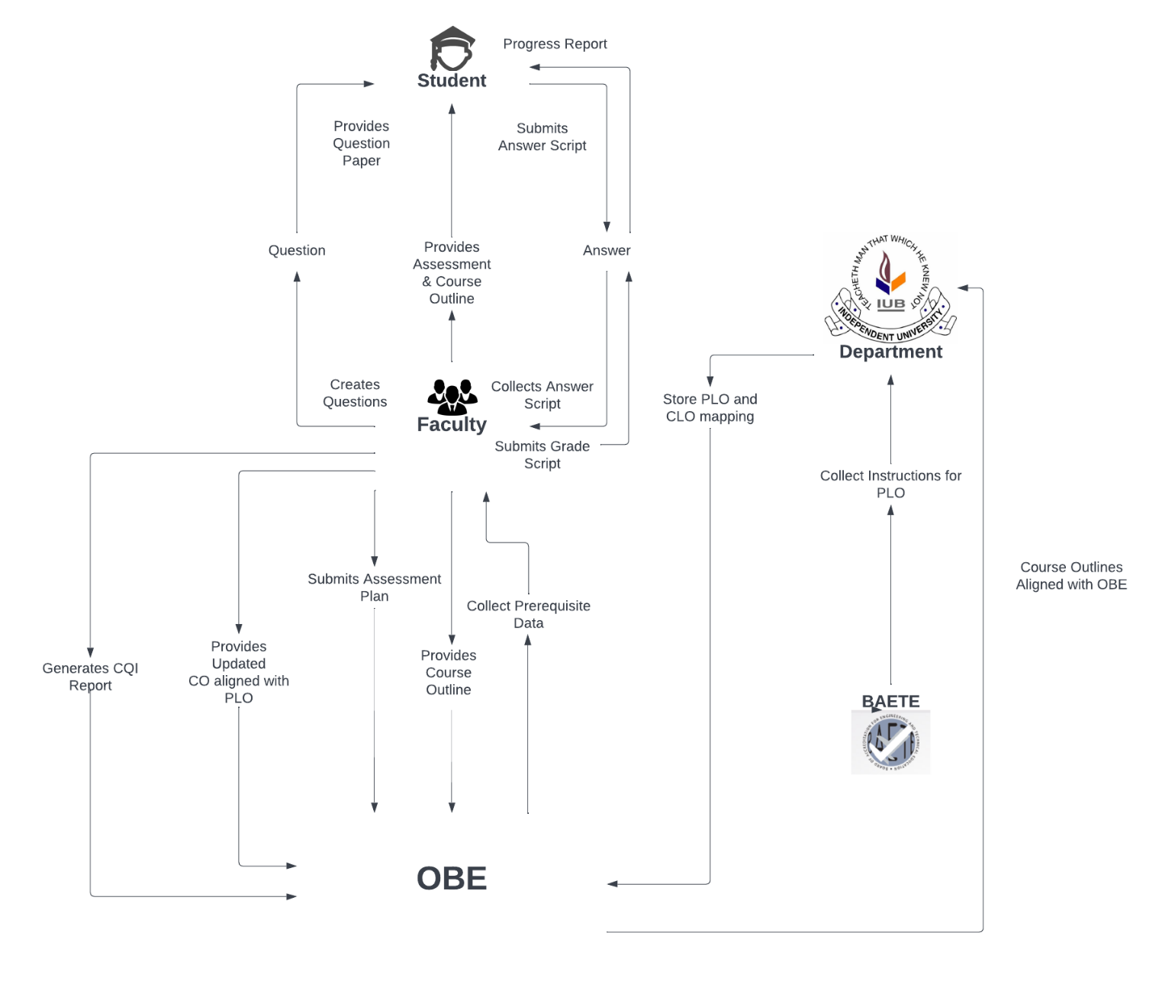

**Figure: Rich Picture As-Is**

## **B. PROCESSES ALONG WITH SIX SYSTEM ELEMENTS**

|  |  |  |  |  |  |  |
| --- | --- | --- | --- | --- | --- | --- |
| **Process Name** | System Roles | | | | | |
| **Human** | **Non-Computing Hardware** | **Computing**  **Hardware** | **Software** | **Database** | **Network &**  **Communication** |
| **1. Collect instructions for PLO and store PLO and CLO mapping** | **Department Head**:  1. Navigate to BAETE's website  2. Gains access to accreditation manual from the website  3.  Read the PLO instructions from the manual.  4. Follow the instructions as specified in the accreditation manual to graduate based on educational criteria.  5.Before commencing with mapping, the associated department head must set the number of PLO’s for each course.  For instance: We have 12 PLO’s (According to the updated BAETE manual, dated 07.06.2022) and we have to map those PLO’s with courses such that each course will get at least 6 PLO’s mapped to them and each PLO will get at least 7 courses for mapping, so we have to choose the most important and specific ones.  6. The faculty member has to:  a.  Collect the previous outline and pinpoint the main objectives of a single course  b. Map the pinpointed objectives with the learning taxonomy.  c. Set the program learning outcome based on Course outcome.  d. Set the assessment initial planning with the course outcome.  7. Store the Accreditation Manual paper and initial mapping paper into OBE’s storage  8. Faculty collects all information from OBE’s storage which is stored by the department. | **Pen and Paper:**  CO and PLO mapping with courses are mapped on paper using a pen. | **Computer**  1) To navigate to the website of BAETE to collect the accreditation manual  2) Also used for making softcopies of PLO and CO mapping.  **Printer:**  To print the accreditation manual paper and softcopy of CO and PLO paper. | **Browsing:**  To browse like  Edge, Brave  Chrome, Mozilla  Safari etc.  **Microsoft Word:**  Prepare word files for the mapping of PLO and CO documents.  **PDF viewer:**  To view the BAETE accreditation manual from the BAETE website.  Example:  Adobe Reader Edge etc  **Drive:**  Used to transfer all PLO and CLO mapping information to OBE storage.    **Operating**  **System:**  Any OS  may be  used. e.g.  Windows, Linux  MacOS. | **Microsoft Excel Files:**  Access the data to view or edit the PLO's Curriculum & CO’s initial mapping. | **Internet:**  Search Engines such as- Google, Yahoo and Bing can be used to enter the BAETE website to collect the accreditation manual and update PLO’s, Also, to collect information related to courses found in IUB website. |
| **2. Map updated course outline aligned with OBE** | **Faculty:**  1. Collect all information from OBE’s storage which is stored by the department.  2. In the event that the faculty wants to change something in PLO vs CO initial mapping, they can amend and remap the PLO vs CO and store it in OBE’s storage  .  3. If a faculty wants to check the previous course outline they can collect it from OBE storage.  4. Then if needed they have to prepare the new course outline with course outcomes.  5. Now identify the  main objectives for each course.  6. Then map CO's with PLO’s:  a) The first CO, or  CO1 is considered as a "First level of taxonomy (remembering)" Provided in ("Level of learning bloom Taxonomy") of this course.  But in the REVISED Bloom’s taxonomy as: (Remembering, Understanding, Applying, Analysing, Evaluation, and Creating)  b) Now make the PLO1, which is more appropriate for the first level of CO as CO1.  c) Then after this, note down the reasonings for this process.  7.Then they have to find the course outline of a single course and map it with the course outline to PLO and store it in OBE’s storage.  8. Faculty members then make course assessment based on the updated CO and PLO mapping:  a) In this course the First quiz will test the fundamental theory.  There are 4 CO's (CO1, CO2, CO3, CO4).  CO1 is mapped with PLO (Engineering Knowledge) which tests the basic knowledge for the course.  This is also used in (Quiz-2, Mid, Quiz-3,4 and Final).  b) In the 2nd Exam: Students read out the problems and then formulate using the necessary principles of mathematics.  For this, CO2 is mapped by the "Quiz-2" and "MID term" exam. In this way faculty can create assessment planning and also update course outline.  9. Store course assessments and course outline information to OBE storage. | **Pen and Paper:**  Instructions of Course Outline and course assessment planning as CO and PLO basis details are printed on paper. | **Computer:**  Computers are used to prepare Course Outline and Assessment Planning using  current CO and PLO mapping, also for making softcopies of Course Outline and Assessment Planning.  **Printer:**  To print the softcopy of Course Outline and assessment planning. | **Microsoft**  **Word:**  Used to Type in the Course Outline and Assessment Planning and to  generate a printable pdf.  **Operating**  **System:**  Any OS can be used. e.g.  Windows, Linux, MacOS.  **Adobe**  **Acrobat**  **Reader:**  For viewing the assessment planning paper and course outline in pdf format. | **Docx/pdf Files:**  To compile and edit information regarding: Course Outline, Assessment Planning and are stored as docx/pdf.  **Department**  **Storage:**  A hard copy of OBE Course Outline docs/pdf file is stored in the Department  storage. | **Internet:**  Online platforms such as- Google docs can be used to prepare docx files for Course Outline and Assessment Paper. |
| **3. Course progress** | **Faculty:**  1. Faculty members design the question paper based on the current CO and PLO mapping.  2. Creates and connects individual questions with the COs based on the course’s assessment table.  3.The question paper is sent to other faculties who also have the same course in order to  check the question paper.  4. Said faculties will then verify the question paper, check for any errors and correct them.  5. Prepare SODs and invigilators for the exam.  6. Return the question paper to the designated faculty.  7. Contacts with the exam committee to manage exam date, time and place by providing the necessary information about the exam i.e. total no. of students and total exam duration.  8. Receives confirmation and schedule about the exam that was requested.  9. Publish information about the exam to the students i.e. exam date, time and place and syllabus to the students.  **Examination committee:**  After getting notification from the faculty members about the exam, they need to fix a particular date, time and place for the examination and confirm the date of examination, time, room number to the faculty member.  Student:  1. Receives information about the examination from the faculty, i.e. the syllabus for that upcoming exam, the date and time and where the exam will be held.  2. Attend the exam at the correct time and place and give the exam.  3. When done with the exam, submit the answer scripts to the SODs or faculty and leave the examination hall. | **Stationery:**  1) Paper is used to print the question papers.  2) Supply pen, pencil, eraser, sharpener, stapler, ruler and equipment that are required during the examination.  **Chairs and**  **Table**  To sit for the exam..    **Room** Designated room for examination. | **Computer/**  **Laptop:**  1. A computer is needed for preparing the question paper.  2. For coding or  open book exams in some courses, computers are required.  3.To prepare the question paper they use a docs/pdf file.  4. For printing question papers.  **Scientific**  **Calculators:**  Some exams require the use of scientific calculators like Mathematics, Physics, Accounting etc.  **Printers & photocopy machine:**  Instructors use it for printing question papers. | **Microsoft Word:**  It is used by the faculty for typing and preparing the questions and generating docs.  **Operating System**  Any OS may be used. e.g.Windows, Linux, MacOS.  **Adobe Acrobat Reader**  For viewing the question paper in pdf format  **Google Classroom**  Used by faculties and students during online examinations. | **Docx/pdf Files:**  To compile and edit information regarding: Course Outline, Assessment Planning, Questions and Papers are stored as docx/pdf.    **Department**  **Storage:**  A hardcopy of OBE’s Course Outline docs/pdf file is stored in the Department  storage. | **Internet:**  1.Used by students during open book exams  2.Online platforms such as- Google docs may be used to prepare question papers for examination  3. Examiners may need to confirm exam date, time and room no. So in order to send an updated notification at that time, they use the internet. |
| **4.  Generate Progress Report based on Answer Scripts** | **Faculty:**  1. Faculty members must receive all response scripts from the answer bank after taking the assessment.  2. Faculty members mark the answer sheets after checking.  3. After checking all scripts, distribute them to students for rechecking and wait for their feedback.  4. After resolving problems with students about exam papers, faculty members will create sample solution papers for the given questions in exams and store those to the OBE’s storage.  5. Faculty members have to prepare grade sheets as per course outline and store the respective data in the OBE’s storage.  6. These reports must be sent to the department head by faculty members.  7. If department heads have any queries about the marks or grade sheets, faculty members will give feedback accordingly.  **Student:**  1. Students will collect the scripts from faculty members and check their marks  .  2. If they have any queries they’ll request the faculty to recheck their answer scripts and wait for the feedback  **Department Head:**  1.Check the final grades with marks in excel files provided by the faculty members  2. If there is any query for the marks or grade sheet, department heads will contact the responsible faculty for that particular course. | **Stationary:**  1)Pen and  paper used to  check Answer Scripts for evaluating.  Also, for creating manual grade sheets. | **Computer/**  **Laptop**  To prepare the excel file of the grade sheet    **Scientific Calculators:**  Some exams require the use of scientific calculators like Mathematics, Physics, Accounting etc..  **Printers & photocopy machine:**  Instructors  use it for printing grade sheets. | **Microsoft Excel:**  Typing the ID and Marks to generate a printable excel file.  **Operating System:**  Any OS may be used. e.g. Windows, Linux, MacOS. | **Microsoft Excel:**  Used for storing exam marks and calculating ID-wise final grades. | **Internet:**  Used by faculty members to create online excel files and also for sharing excel files. |
| **5.Generate CQI Report** | **Faculty Member:**  1. Collect ALL assessment reports of that semester from OBE  2. Check the percentage under a specific PO.  3. Identify the lowest percentage  4. Figure out the reason for the lowest percentages.  5. Solve those problems. For that faculties can do the following:      a) Make changes to the Course Outline and  Assessment planning      b) Update the CO vs PLO mapping.  6. Make Suggestions for improving student performance.  7. Compile all      the data and generate report  8. Store the report in the OBE storage.    **OBE Storage:**  Receive  report from the faculty member. | **Stationary:**  **Pen and Paper**:  Used if a faculty member wants to write something on the report.  **Marker Pen:**  Used if a faculty member needs to mark something on the report. | **Computer**  1) Used to prepare the CQI report in a printable format.  2. Used to edit the Excel file.    **Printer**  To print the assessment report or CQI report. | **Operating**  **System**  Any OS  Can be  used. e.g.  Windows, Linux  MacOS.    **Adobe**  **Acrobat**  **Reader:**  To view the report in pdf format.  **Web Browser:**  To send and receive the report through email. | **Docx/pdf Files:**  To view the CQI report which is prepared in the docx or pdf file.  **Department**  **Storage**  A hardcopy of CQI reports will be stored in the department storage. | **Internet**  Online platforms such as- Google docs can be used to prepare docx files for CQI reports. |

**Table: Six Element Analysis As-Is**

## **C. PROCESS DIAGRAM (AS IS)**

## 

**Figure: Process diagram of collect the PLO and store the initial mapping (as-is)**

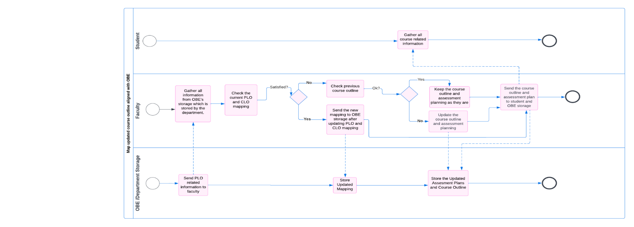

**Figure: Process diagram of collect the PLO and store the initial mapping (as-is)**

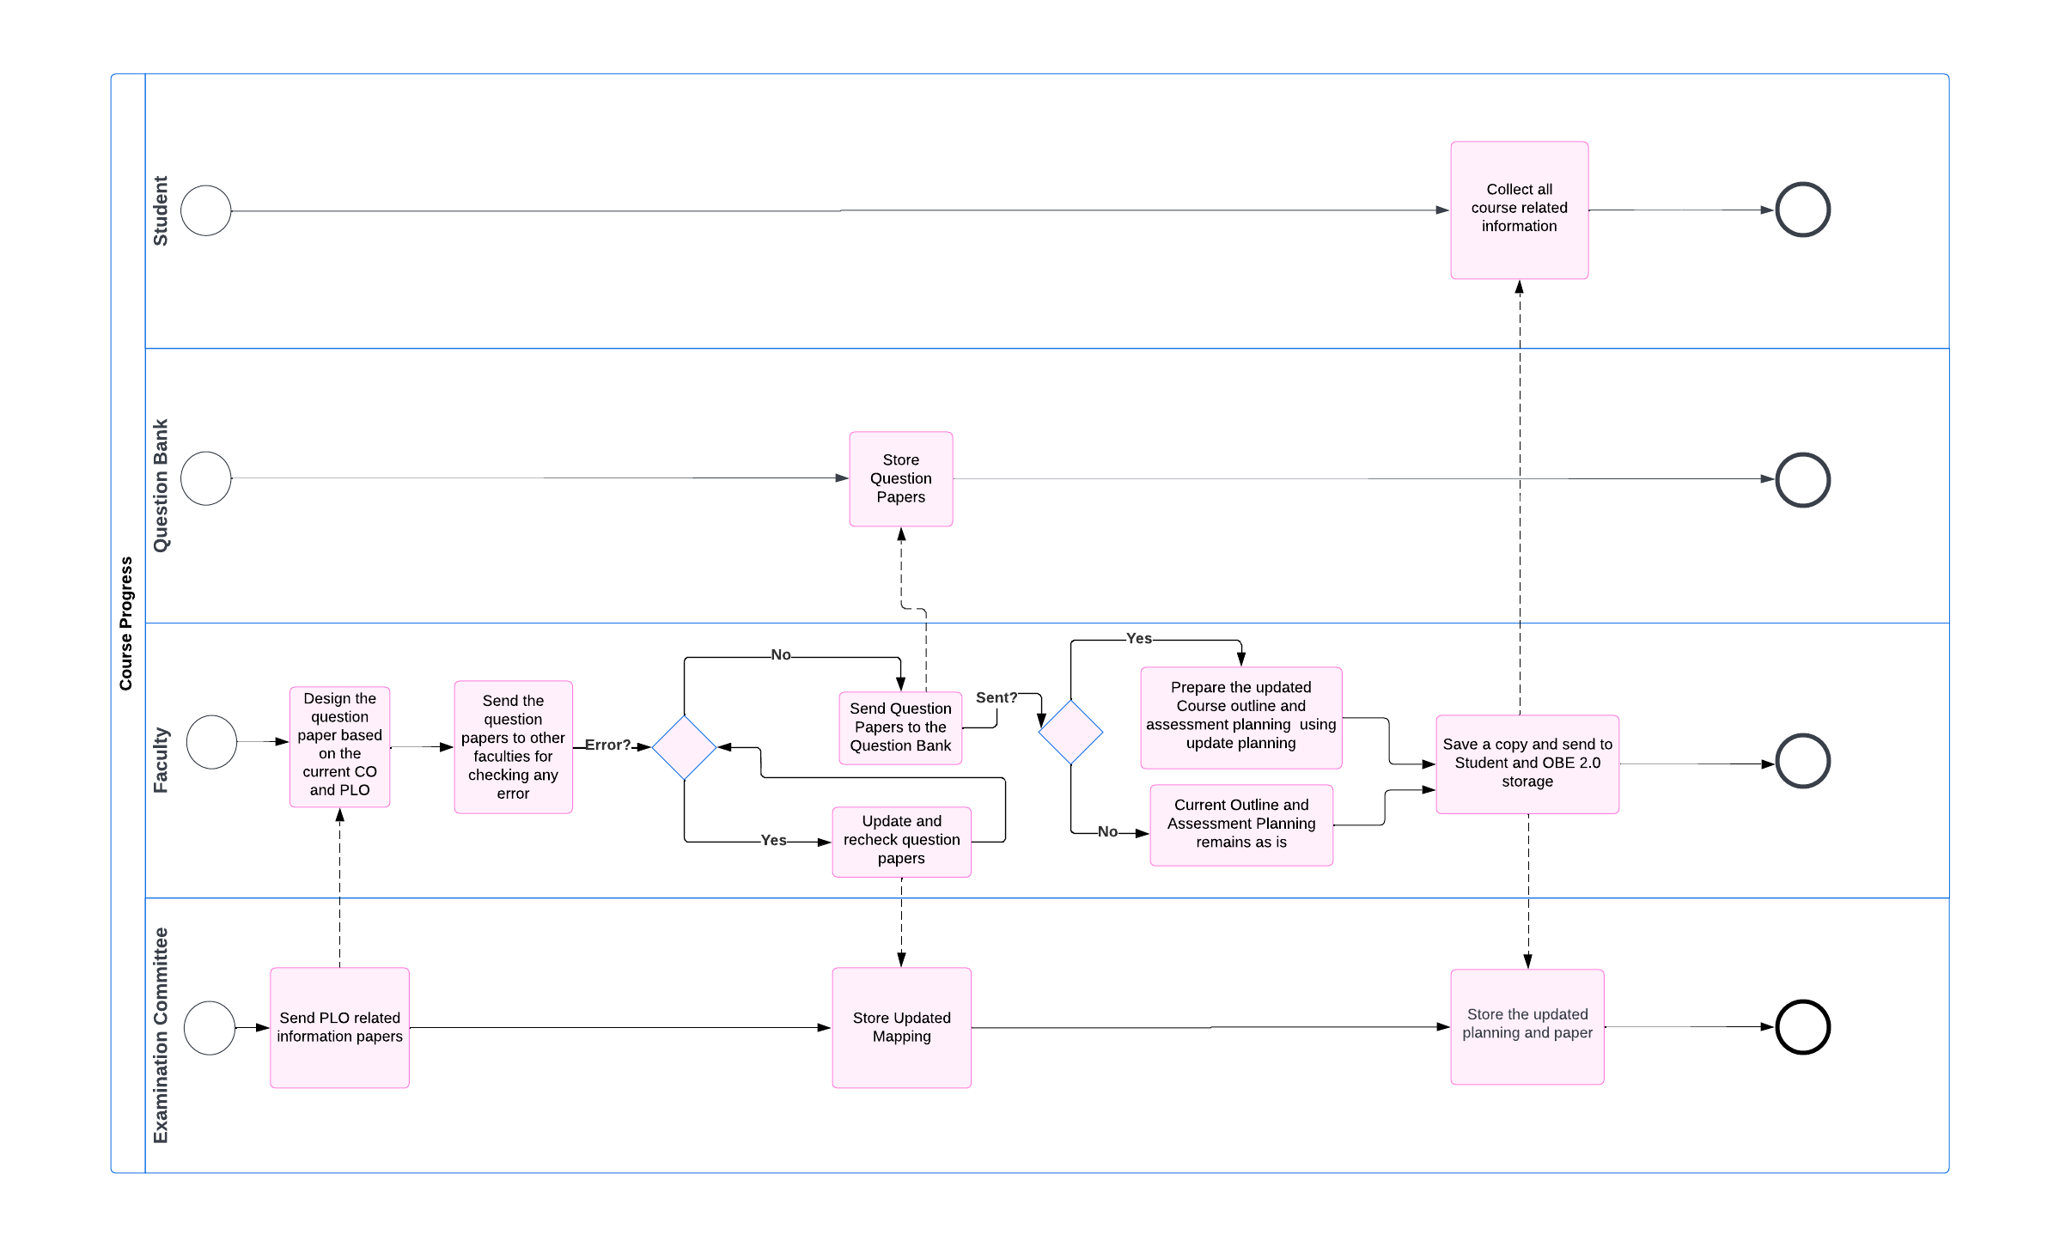

**Figure: Course Progress**

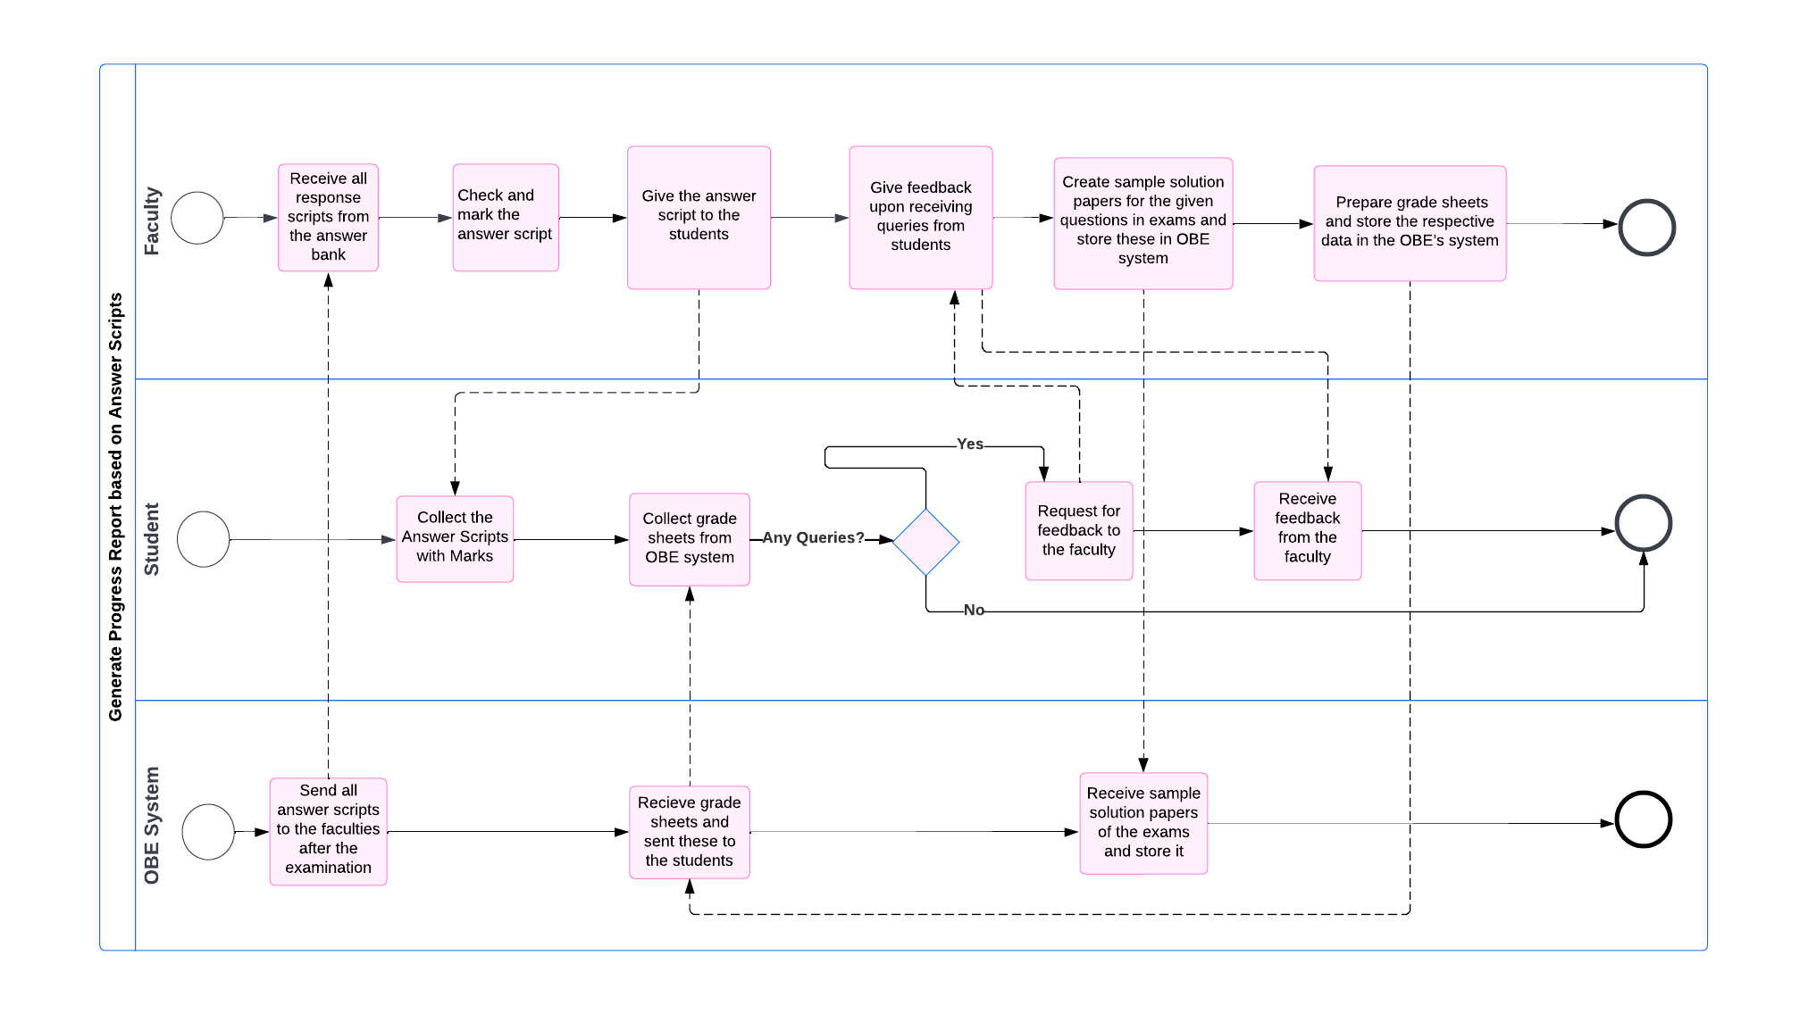

**Figure: Process diagram of generate progress report based on answer scripts**

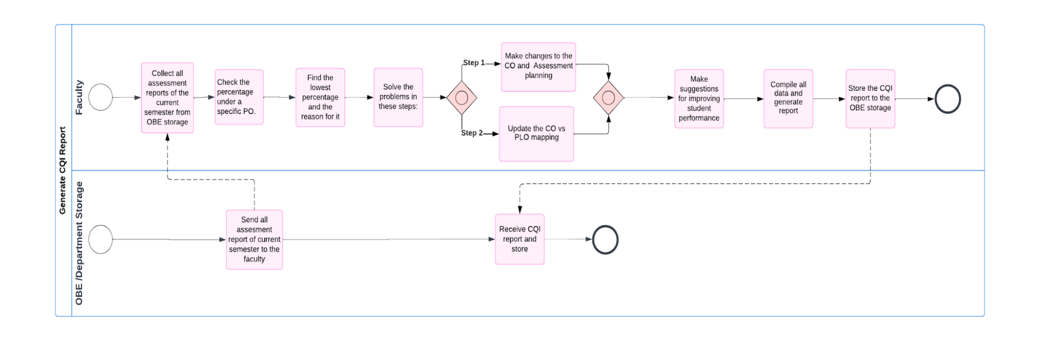

**Figure: Process diagram of generate CQI report**

## **D. EXISTING PROBLEMS & ANALYSIS OF THE PROBLEM**

|  |  |  |  |  |
| --- | --- | --- | --- | --- |
| **PP Process Name** | **Stakeholders** | **Concerns (problems)** | **Analysis (Reason of the Problem)** | **Proposed Solution** |
| **Update the Initial Mapping of PLO (Course wise)** | Department | With the current system, the department has to manually do the mapping of each course using pen and paper. Thus, if updates are required, then the department has to prepare the mapping again manually. This is a major issue. | In the current system, the department has to come up with the mapping by hand and that is time consuming, adding on extra work and not maximizing use of resources. | As such, these are the ways to combat this problem:  1. Each PLO and course will be assigned a weight or level.  2. Based on this weight/level, the PLO and Courses are mapped. The initial mapping would be done using the generated matrix.  3. The admin can easily update the mapping based on the number of instances of courses having PLO and of PLO having courses. |
| **Checking scripts and preparing grade sheets.** | Faculty members | 1. Individual faculty members check answer scripts and mark them manually.  2. The members have to calculate and manually tabulate the marks in grade sheets and then grade them manually. | Manually checking answer scripts is a time-consuming process given the number of students and then the grade sheets have to be made manually as well. This increases the chances of error while checking the scripts. | Automating can solve these issues:   1. For MCQ type exams, the system will automatically check scripts and supply the grade sheet. For instance, if the exam is in quiz format, then our system displays the marks of the MCQs and provides the answer scripts as well. 2. For CQ type exams, faculty members have to check the answer papers, mark them and give grades manually. However, after submitting the marks, the grade sheet is generated by the system. Students will receive the marks and grades from the system. |
| **Suggest questions from the question bank while making the question paper.** | Faculty | More time and effort are used to design questions, as each time the faculty will have to map the COs with the questions and manually create the question paper. | It is not possible to efficiently recycle all known previous question papers and as a result, the question papers are discarded after an exam ends. The faculty members do not have an exam history or folder of the past papers of an exam. | In our system, soft copy versions of all verified question papers will be stored and can be accessed when the faculty is designing a question paper. For instance, if a faculty is about to make a midterm question paper for a course, they will be suggested to browse the exam history of the midterm papers of that course. This way both the effort and time required in designing a paper is reduced. |
| **Automated mapping for a specific course and prepare Course assessment planning** | Faculty | As a faculty is preparing the course planning, they have to go by the previous PLO or initial mapping of PLO, which won’t always be consistent and is time consuming.  When mapping PLO and CO, they have to keep track of the number of PLO’s they are mapping, which can get complicated and pose other problems. | In the current system, the faculty has to prepare the mappings manually by themselves, so there are more chances of errors and problems arising when they are mapping PLO and CO. | To solve this, in our system, there will be predefined PLO labels and course labels.  The system will suggest the number of CO and number of assessments, and if the faculty is satisfied with that, then  a table will be generated for them of the mapping of the CO and assessment. (If they are not satisfied, they can update the mappings.) |
| **Generate**  **CQI report** | Faculty Members’  OBE 2.0 Storage | 1. The progress report is collected from the OBE.  2. The percentage has to be checked manually and then faculty membershave to find the lowest percentage against each PLO of a student, for all PLOs.  3. The data has to be compiled into reports. | These tasks are time-consuming. Firstly, the report has to be passed from OBEto the faculty, which adds time. Additionally, it is more likely for faculty members to make errors finding the lowest percentage. Some inputs may be accidentally entered wrong when the faculty is compiling data. Furthermore, it is unnecessarily complicated to identify problems and find solutions since each semester will be subjected to change depending on the students’ performance. | In our system, a CQI report with the following will be generated:     1. A graph displaying the number of students enrolled per department for a specified period of time/semesters. 2. Based on GPA, a course-wise student performance trend for a specified period of time/semesters. 3. Based on GPA, instructor-wise student performance trend for a specified period of time/semesters. 4. For a chosen course, instructor-wise student performance trend for a specified period of time/semesters. 5. The percentage of PLO corresponding to the specific course and the lowest percentage of each PLO for each student. Give possible solutions or suggestions about how to improve the students’ performance. 6. A comparison of the attempted PLO percentage against the successfully achieved PLO percentage. 7. A comparison of a particular course’s expected PLO achievement against the actual PLO achievement for a specified period of time/semesters. |

**Table: Problem Analysis**

## **E. DESCRIBE PROPOSED BUSINESS SYSTEM (WITH RICH PICTURE)**

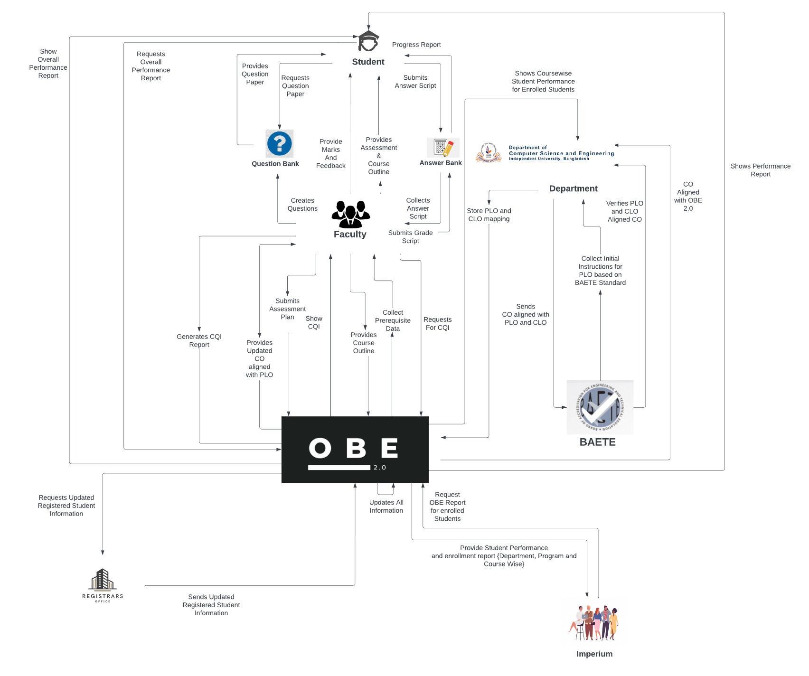**Figure: Rich Picture To-Be**

## **F. PROPOSED PROCESSES ALONG WITH SIX SYSTEM ELEMENTS.**

|  |  |  |  |  |  |  |
| --- | --- | --- | --- | --- | --- | --- |
| **Process Name** | System Roles | | | | | |
| **Human** | **Non-Computing Hardware** | **Computing**  **Hardware** | **Software** | **Database** | **Network &**  **Commination** |
| **1. Review and update the Initial Mapping of PLOs (Course-wise)** | **Department:**  1. Department must enter our system’s website to map the PLO and CLO aligned with CO.  2. Click on mapping to map and a new table is generated and shown.  3. The tables contain the lists of PLOs and all courses. It also shows how a PLO can be mapped to various courses and how many PLOs can be mapped with a specific course.  4. In OBE2.0, the PLO and courses will each have a label and PLO will be shown based on level, which will assist the department to identify the PLO mapping.  5. Then, through a click,the department can store it in our system database. | **Pen & Paper:**  Using pen and paper, PLO and courses are mapped. | **Computer:**  Computer is used to go to our website and update the PLO and Course mapping. Also, the course outline and course details can be viewed. | **OBE 2.0:**  OBE 2.0 is required to update the PLO and CO mapping.  **Operating System:**  Any OS can be used by the users, Windows, Mac, Linux, etc. | **OBE 2.0 Database (unsure):**  The mappings of PLOs and COs are stored here. | **Internet:**  This is an online website, thus the Internet is required to upload the PLO and Course planning. |
| **2. Mapping a specific course automatically and prepare course assessment planning** | **Faculty**  1. The initial mapping of PLO and Course is already done by the department.Faculty members have to enter our website and login with their ID.    2. They can view their assigned course and the PLOs for that course, as suggested by the department.  3. If a report is available, the faculty can view the CQI report and if required, the faculty members can update the PLO mapping.  4. System will provide the faculty with a few suggestions. For example, the number of course outcomes and PLO with the label wise courses, the specific PLOs and the number of assessments, etc. If the faculty wishes to change something, then they have to select the number of CO and map that CO with PLO.    5. Then, they have to select the number of assessments and map those with CO.  6. Faculty saves upon click after updating all the mapping. | **Stationary:**  Paper is used for printing the instructions for the course outline and course assessment planning as CO and PLO based details. | **Computer**:  A computer is important to enter our website and select the PLO and CO mapping, assessment planning and mapping. With a computer or laptop, the course CQI report and course can also be viewed. If there is something to be changed based on the CQI report, then the changes will be made using a computer. | **OBE 2.0:**  OBE 2.0 is required to update the PLO and CO mapping,  assessment and course outcome mapping, etc.  **Operating System:**  The user may use any OS, such as Windows, Mac, Linux, etc. | **OBE 2.0 Database:**  The mappings of PLOs and COs are stored here. | **Internet:**  This is an online website, thus the Internet is required to update the PLO and CO mapping as well as the assessment planning. |
| **3. Course Progress** | **Faculty:**  1. The faculty logs insuccessfully using ID and password.  2. Goes to the question paper creation section.  3. Selects an exam type and dictates the total marks of that examination.  4. Select question number.  5.Creates a particular question in a similar pattern by browsing through the past papers of the same exam type.  6. Specifies the marking for that question.  7. If needed, makes anotherquestion using processes 4-6.  8. Clicks on “Save” and successfully saves the paper asusual.  9. Additionally, include further information regarding the exam. For instance, the duration, topics, etc.  **Student:**  1. The student logs in successfully using ID and password.  2. Clicks on the exam section for the exam history and the upcoming exam announcements for all courses the student is enrolled in during the ongoing semester.  3. By clicking upcoming exams, they can find more exam details like the syllabus.  4. During an exam, do 1 and 2, then click on that assigned exam, and view the information of the question paper such as exam contents and timing.  5. Submit and upload the answer scripts (soft copy) on that exam section.  6. (Optional) Provide feedback via rating on that particular exam. | **Pen and Paper:**  Some of the questions may have to be answered in a paper and scanned for upload. Rough work may be done.    **Calculator, ruler, pencil, eraser, sharpener.**  Necessary tools for coming up with answers and writing them. | **Computer/**  **Laptop/**  **Smartphone:**  Both the students and the faculty need a computer to conduct the examination successfully. | **Internet Browser:**  Suitable internet browsers for website navigation such as Google Chrome, Mozilla Firefox, Safari, etc. | **OBE 2.0 database:**  For storing the faculty and student users and question paper data. | **Internet:**  Used by both the faculty members and students to access the OBE 2.0 software and database. |
| **4. Make grade sheets after checking Answer Scripts** | **Faculty:**  1. The faculty has to input the answers into our system and check the answer script and mark accordingly.  For instance, in a quiz, the website will show the marks and answers for the MCQs.  2. The system prepares mark sheets in excel files which the faculty collects.  **Student:**  1. Students can directly view their marks and the answer script on the website.  2. They can find their grades on the website. | **Paper:**  When the faculty has to print the mark sheets and grade sheets, paper is used. | **Computer/**  **Laptop:**  For both students and faculty to log into the website and check the marks and grades.  **Printer:**  Used to print required documents such as mark sheets. | **OBE 2.0:**  Required for checking answer scripts, marks and grade sheets. | **OBE 2.0:**  Required for storing answer scripts, marks and grade sheets. | **Internet:**  Used by both the faculty members and students to access the OBE 2.0 software and database.      . |
| **5.  Generate CQI report** | **Faculty:**  1. Enter the website.  2. Find and select the course.  3. Upon clicking student performance, the system will display all activities.  4. The CQI report button will display PLO percentage upon click.  5. If a student falls below a certain PLO percentage, the faculty has to note down the reason.  6. The faculty will suggest how the student can improve their performance.  **Department:**  1. Navigate to the website.  2. Upon clicking on student performance, the system will display all activities.  3.  If you click on instructor wise then it will show instructor wise course performance. | **Paper:**  It is used if a faculty wants to print something | **Computer:**  For both students and faculty to log into the website and generate the report.  **Database Server:**  The faculty has access to the database where they can store or update information into the database. | **OBE 2.0:**  The report is generated through the system.  **Operating System:**  The user may use any OS, such as Windows, Mac, Linux, etc. | **OBE 2.0 Database:**  For storing the updated report, the database is used. | **Internet:**  Used by the faculty members to access the OBE 2.0 software and database. |
| **6.  Update Student enrolment information in OBE2.0** | **Registrar Office:**  1. OBE 2.0 notifies the registrar office to update student information.  2. The updated enrolment report for the student is submitted.  **Higher Authority**  **(Imperium):**  1. Requests to access the student enrolment report.  2. In the form of a graph, view the student enrolment report. | **Paper:**  It is used to print something  **Pen:**  It is used to write something on the report. | **Computer:**  For higher authority members and registrar office members to login to the website and conduct their respective tasks.  **Database Server:**  Receiving and sending data to and from the registrar office to store or update information into the database. | **OBE 2.0:**  The system is used to update the student enrolment information.  **Operating System:**  The user may use any OS, such as Windows, Mac, Linux, etc. | **OBE 2.0 Database:**  The updated student enrolment information is stored here. | **Internet:**  The registrar office personnel and higher authority use the internet to access the OBE 2.0 software and the database. |

**Table: Six Element Analysis To-Be**

## **G. PROCESS DIAGRAM (TO BE)**

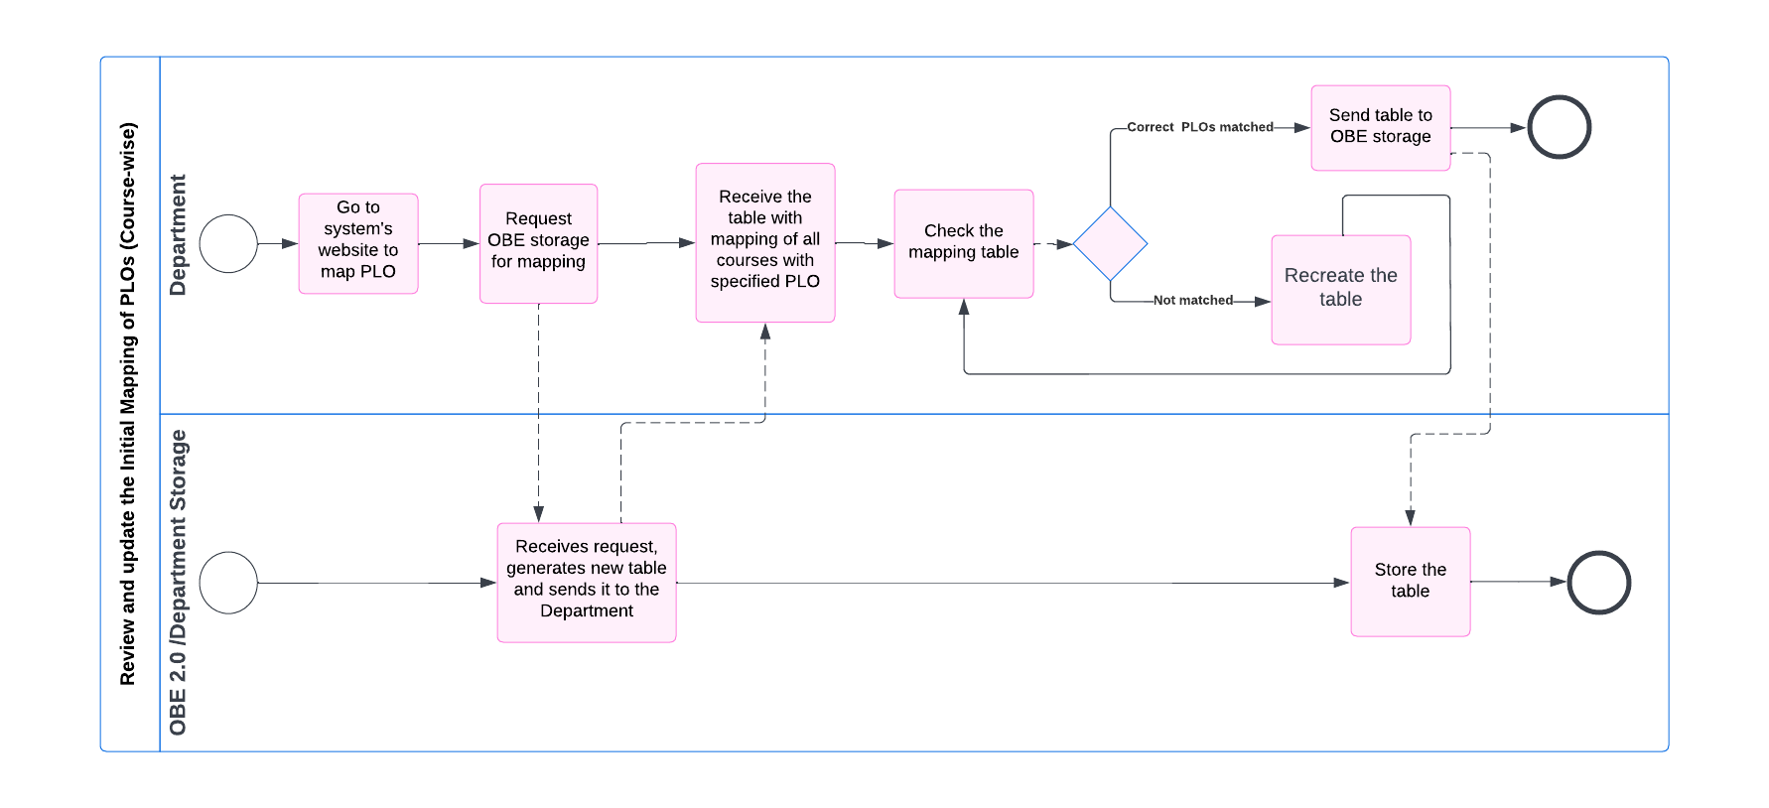

**Fig: Process diagram of review and update the initial mappings of PLOs (course wise)**

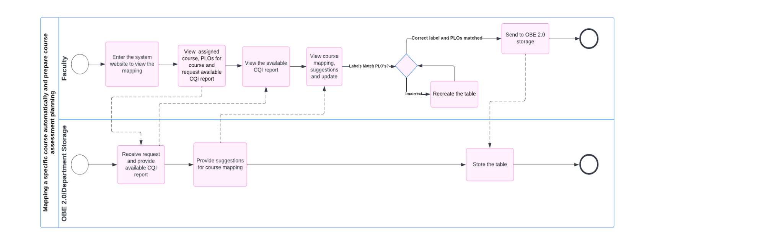

**Fig: Process diagram of mapping a specific course automatically and progress course assessment planning**

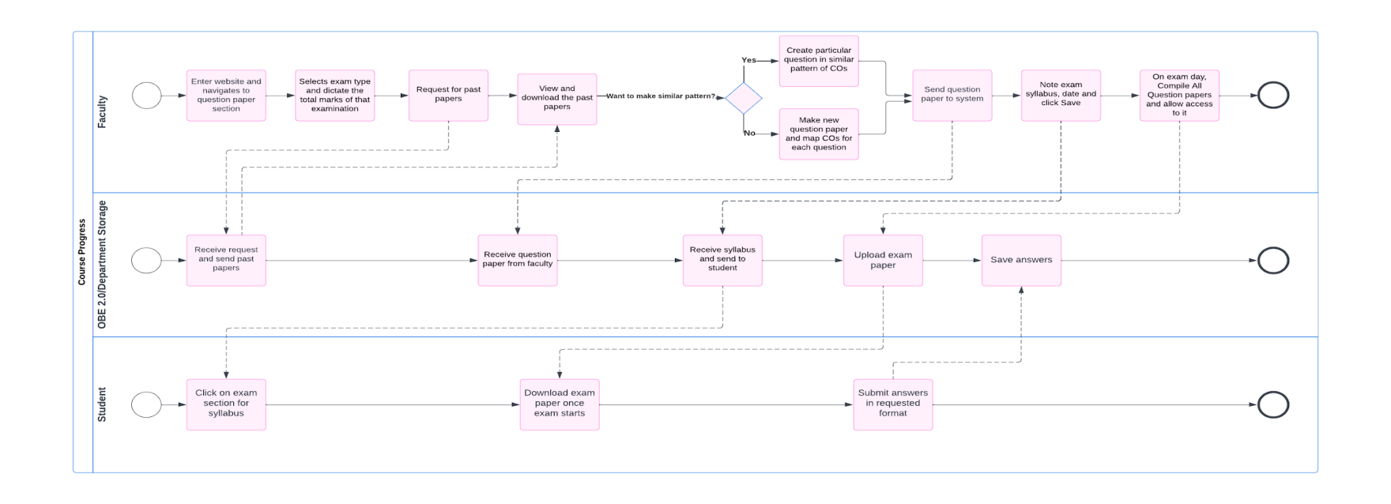

**Fig: Process diagram of course progress**

# 

**Fig: Process diagram of make grade sheets after checking answer scripts**

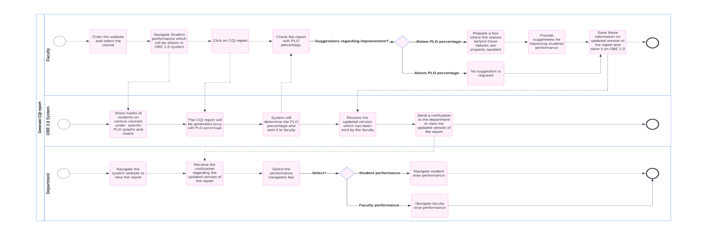

**Fig: Process diagram of generate CQI report**

# 

**Fig: Process diagram of update student enrolment information in OBE2.0**

# CH-3 LOGICAL SYSTEM DESIGN

## **A. BUSINESS RULES**

The OBE2.0 aims to improve the efficiency of monitoring student performance. It uses the data provided by IUB regarding their departments, programs, faculties, students and other relevant information to create a better, time efficient system. All the COs (Course Outcomes) and the mapped PLOs (Program Learning Outcome) are stored in the system and compared with each other so OBE2.0 can generate the result of PLO fulfilment.

In a university, a studentenrolls under a specific degree program, which falls under a certain school.Students usually takecourses as per the curriculum of their respective programs. **STUDENT’s** have ID, name (First Name, Last Name), email, phone number.

Each program belongs to a departmentand the related departments are kept under schools of the University. Each program consists of many courses. Courses are taught by faculties; departments are run by department heads and schools are run by deans.

Under the OBE model, for each program therewill be a set of program learning outcomes **(**PLO). To fulfill the requirement of a degree program a student must achieve the PLOsassociated with that program. To evaluate the students in each course, there are a set of course outcomes (CO) that are mapped with the PLOs of the degree program.

There are different **SCHOOL**s in a university, each of which have ID and name. Under a school, there are different programs. A **PROGRAM** has an ID and a name.

There are many departments under the programs. The **DEPARTMENT** has a department ID and name. In a department, there are faculty members and a department head who is also a faculty. Usually, department heads create the initial mapping of courses with PLOs and store it in the system.

Departments offer multiple courses. A **COURSE** each of has a unique course ID, course title, credit hour, and a course category (ex- foundation, major, minor). Each course contains a course outline through which students will be able to know what they will learn within the course. Students may view one or many course outlines and a single course outline can be viewed by multiple students. A **COURSEOUTLINE** has a unique ID, course objective, course description, course policy, course content, credit hour, course value, year, lesson plan and materials. Under eachcourse, the COs are measured through different assessment techniques. Courses may be retaken by students if they wish to improve their grade.

Courses will be mapped with PLO. **PLO** has a unique ID, name, details, level.

A course has multiple course outcomes. A single CO can be mapped with multiple PLO. Every **CO** has a unique ID, number, level, description. It should be noted that, mapping of CO and PLO are corelated to each other.

A student may fail to fulfil a PLO in a course but they can fulfil the requirement by achieving the PLO from another course higher than the previous course. The PLO percentage is tracked for progress purposes as well as comparison between sets of students, where one might have achieved a certain PLO in all courses that had it, and the other achieved it in fewer courses. COs are also tracked.

Students are required to complete the courses associated with the programs to fulfil the requirement of the degree so for each semester. Every course has at least one section and a course may have multiple sections. A **SECTION** has ID, section no, room no, total no. of enrolments, student capacity, class time, semester and year.

Every semester, faculty members are assigned to the courses in specific sections. A faculty member may be assigned to multiple sections of a single course. **FACULTY** members have a unique ID, name (first name, last name), email and contact number. In case a student can’t fulfil a PLO that they already fulfilled in the previous course, it can be misleading, and the decision on how to handle such cases might be reserved by the faculty members of the courses.

In every section, there are multiple assessments. In **ASSESSMENT**, there are assessment ID, bloom level, bloom category, marks. Each assessment has a main assessment which is a part of itself. In **MAIN ASSESSMENT**, there are assessment type and total duration. The existence of an assessment data is dependent on the existence of the main assessment data. If main assessment data is removed, then assessment data is also removed.

Under an assessment, there are multiple questions. In the **QUESTION** section, there are question ID, question type, question detail and sample answers.

Faculty members will evaluate the exams after students have taken them. **EVALUATION** has a unique ID, obtained marks and the students’ answer. The faculty members evaluate the COs achieved and mapped PLOs achieved by each student in a course. To reduce workload of the faculty, the OBE2.0 system will have automated checking of the scripts through the help of the sample answer and make evaluation reports using the marks generated.

## **B. ERD**

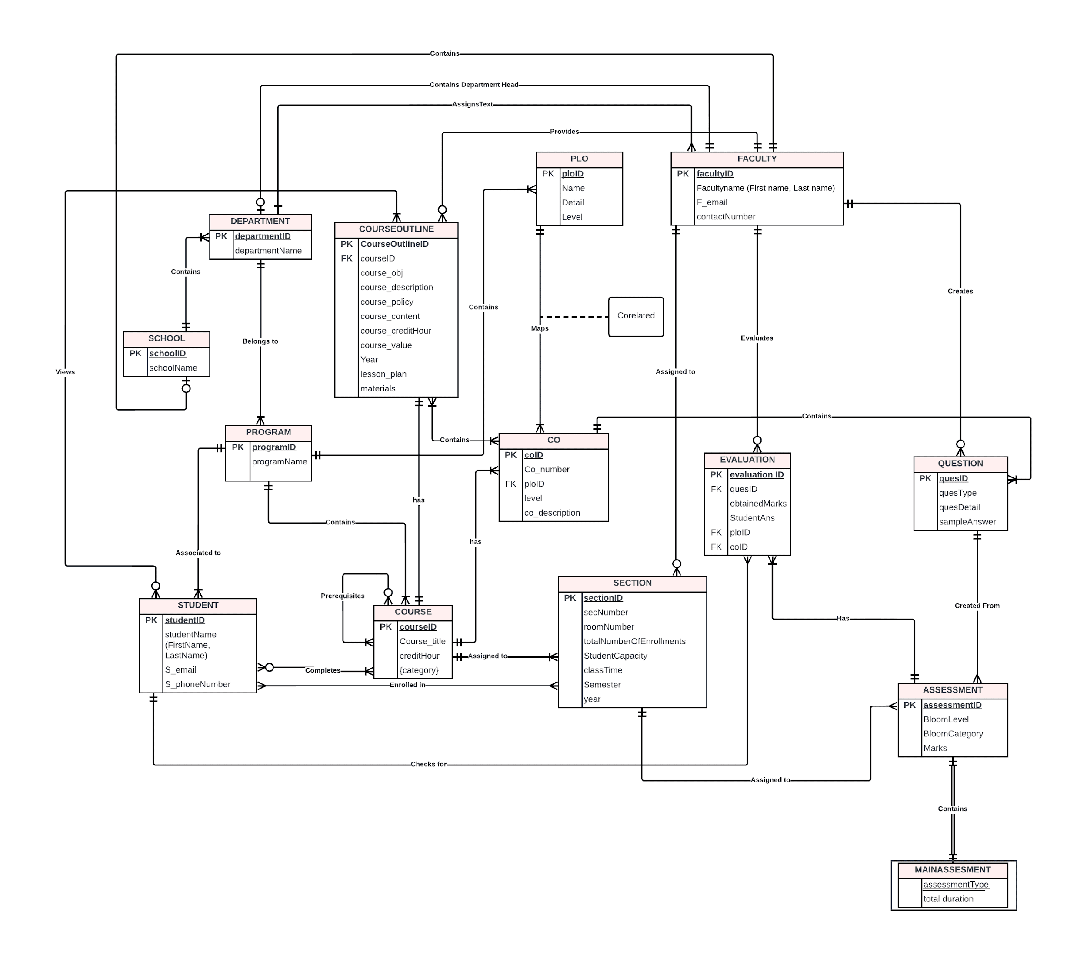

## **C. ERD TO RELATIONS**

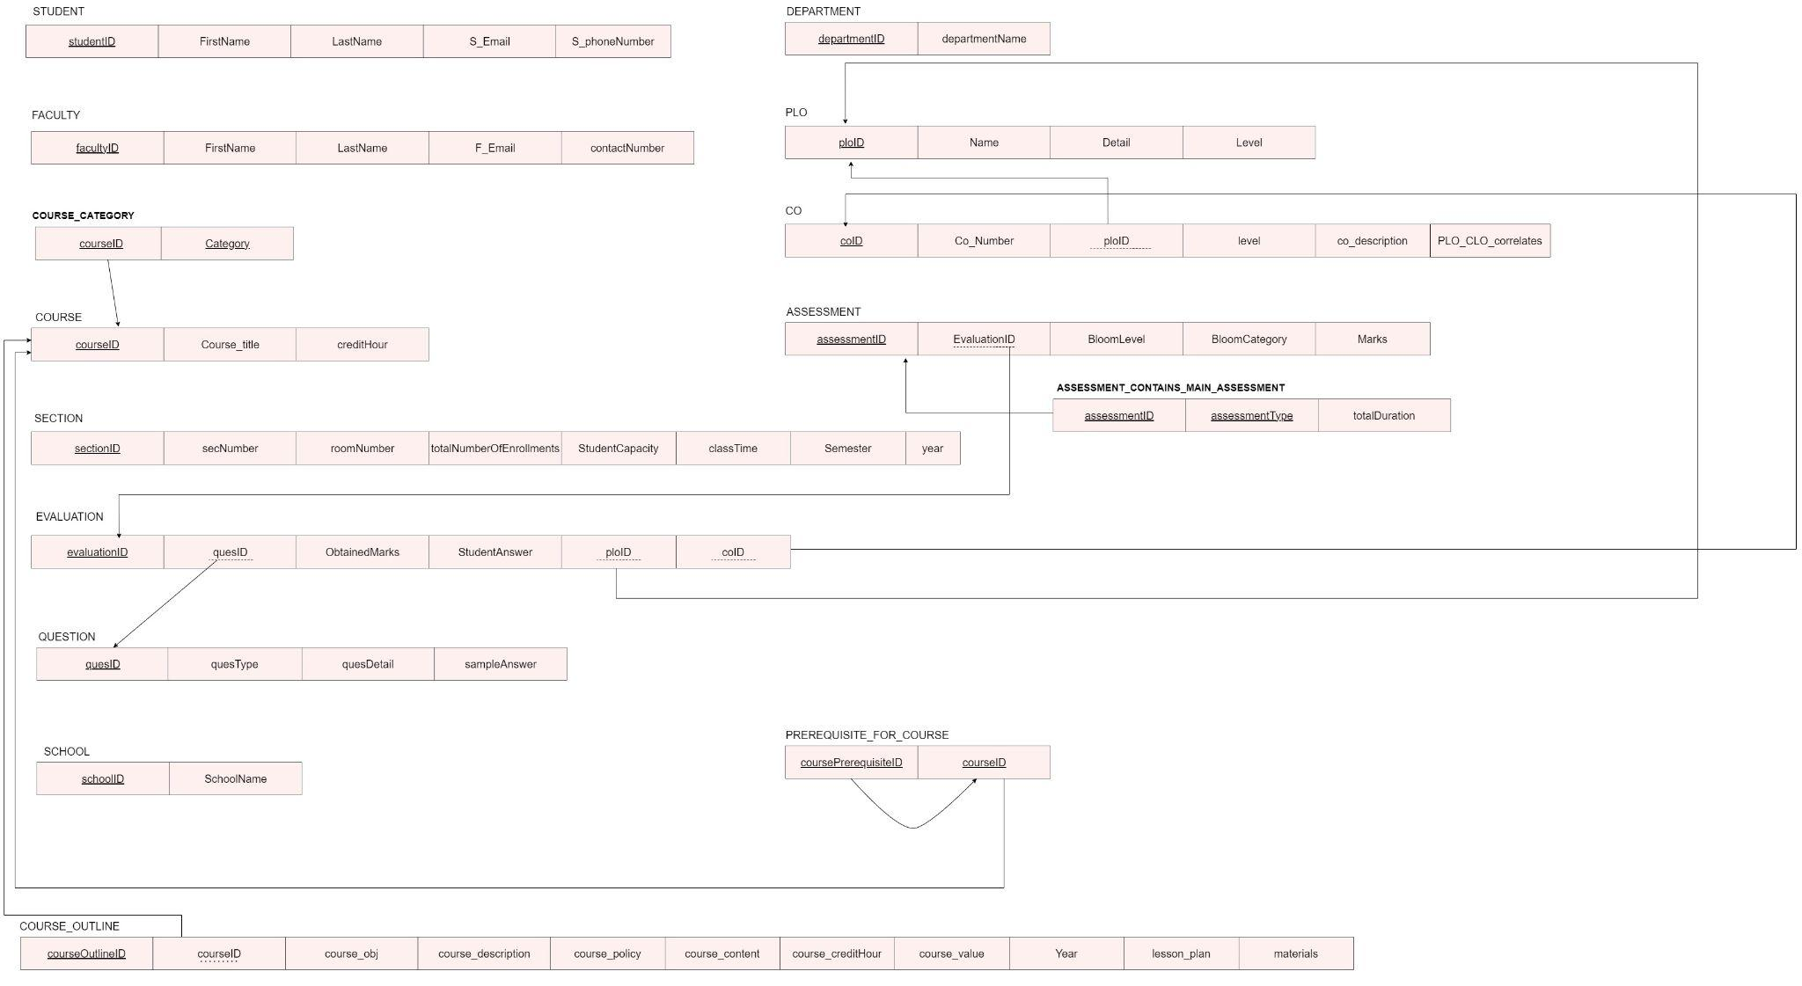

## **D. NORMALIZATION**

|  |  |  |  |  |  |
| --- | --- | --- | --- | --- | --- |
| **Student** | studentID | t1 | **Department** | departmentID | d1 |
| FirstName | t2 | departmentName | d2 |
| LastName | t3 | **PLO** | ploID | p1 |
| S_email | t4 | Name | p2 |
| S_phoneNumber | t5 | Detail | p3 |
| **Faculty** | facultyID | f1 | Level | p4 |
| FirstName | f2 | **CO** | coID | c1 |
| LastName | f3 | Co_Number | c2 |
| F_email | f4 | ploID | p1 |
| contactNumber | f5 | level | c3 |
| **Course Category** | courseID | o1 | co_description | c4 |
| Category | v1 | º…kjåœPLO_CLO correlates | c5 |
| **Course** | courseID | o1 | **Assessment** | assesmentID | a1 |
| Course_Title | o2 | EvaluationID | e1 |
| creditHour | o3 | BloomLevel | a2 |
| **Section** | sectionID | b1 | BloomCategory | a3 |
| secNumber | b2 | wq89Marks | a4 |
| roomNumber | b3 |
| totalNumberofEnrollments | b4 |
| StudentCapacity | b5 | **Assesment_Contains_Main_Assesment** | assesmentID | a1 |
| classTime | b6 | assesmentType | r1 |
| Semester | b7 | totalDuration | r2 |
| year | b8 | **Question** | quesID | q1 |
| **Evaluation** | evaluationID | e1 | quesType | q2 |
| quesID | q1 | quesDetail | q3 |
| ObtainedMarks | e2 | sampleAnswer | q4 |
| StudentAnswers | e3 | **Prerequisite for course** | coursePrerequisiteID | u1 |
| ploID | p1 | courseID | o1 |
| coID | c1 | **Course Outline** | courseOutlineID | w1 |
| **School** | schoolID | s1 | courseID | o1 |
| SchoolName | s2 | course_obj | w2 |
|  | | | course_description | w3 |
| course_policy | w4 |
| course_content | w5 |
| course_creditHour | w6 |
| course_value | w7 |
| Year | w8 |
| lesson_plan | w9 |
| materials | w10 |

|  |  |
| --- | --- |
| t1→ | t2, t3, t4, t5 |
| d1→ | d2 |
| f1→ | f2, f3, f4, f5 |
| p1→ | p2, p3, p4 |
| c1→ | c2, p1, c3, c4, c5 |
| o1→ | o2, o3, v1, u1, w1 |
| a1→ | e1, a2, a3, a4, r1, r2 |
| b1→ | b2, b3, b4, b5, b6, b7, b8 |
| e1→ | q1, e2, e3, p1, c1 |
| q1→ | q2, q3, q4 |
| s1→ | s2 |
| w1→ | w2, w3, w4, w5, w6, w7, w8, w9, w10 |

|  |  |
| --- | --- |
| studentID→ | FirstName, LastName, S_email, S_phoneNumber |
| departmentID→ | departmentName |
| facultyID→ | FirstName, LastName, F_email ,contactNumber |
| coID→ | Co_Number, ploID, level, co_description, PLO_CLO correlates |
| courseID→ | Course_Title, creditHour, Category, coursePrerequisiteID, courseOutlineID |
| assesmentID→ | evaluationID, BloomLevel, BloomCategory, Marks, assesmentType, totalDuration |
| sectionID→ | secNumber, roomNumber, totalNumberofEnrollments, StudentCapacity, classTime, Semester, year |
| evaluationID→ | quesID, ObtainedMarks, StudentAnswers, ploID, coID |
| quesID→ | quesType, quesDetail, sampleAnswer |
| schoolID→ | SchoolName |
| courseOutlineID→ | course_obj, course_description, course_policy, course_content, course_creditHour, course_value, Year, lesson_plan, materials |

**1nF**

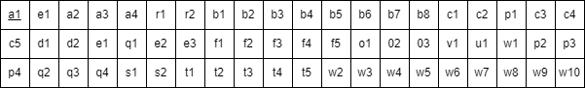

**2nF**

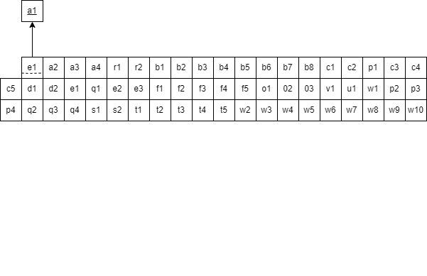

**3NF**

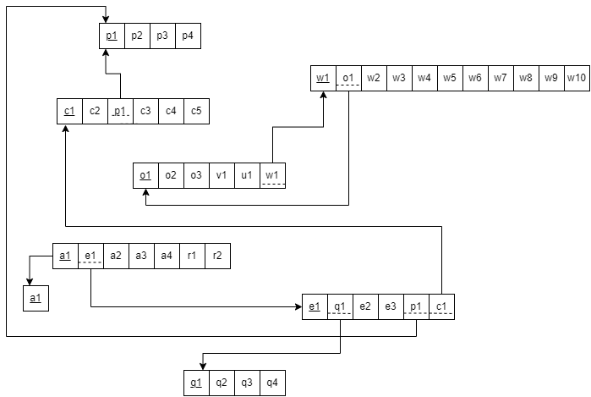

**BCNF**

In this stage of our normalization, no non-key attribute can identify any primary key or part of the primary key. So, we can say that all relations are already in BCNF.

## **E. DATA DICTIONARY**

**School**

|  |  |  |  |
| --- | --- | --- | --- |
| **Name** | **Type** | **Size** | **Remark** |
| schoolID | VARCHAR | 6 | This is the Primary Key of School. |
| schoolName | VARCHAR | 45 | This is the name of the School.  Example: “School of Engineering, Technology and Science” |

**Student**

|  |  |  |  |
| --- | --- | --- | --- |
| **Name** | **Data Type** | **Size** | **Remark** |
| studentID | VARCHAR | 7 | This is the primary key of this relationship. This contains the ID of the student.  Example : “1820735” |
| FirstName | VARCHAR | 30 | This is the first name of the student.  Example : “Nahiyan” |
| LastName | VARCHAR | 15 | This is the last name of the student.  Example : “Tajnoor” |
| S_email | VARCHAR | 30 | This is the email address of the Student.  Example: “1830022@iub.edu.bd” |
| S_phoneNumber | VARCHAR | 14 | This is the phone number of the Student. |

**Department**

|  |  |  |  |
| --- | --- | --- | --- |
| **Name** | **Data Type** | **Size** | **Remark** |
| departmentID | VARCHAR | 7 | This is the Primary Key of the Department.  Example: “CSE” |
| departmentName | VARCHAR | 43 | Name of a particular department  Example” School of Computer Science and Engineering |

**Program**

|  |  |  |  |
| --- | --- | --- | --- |
| **Name** | **Data Type** | **Size** | **Remark** |
| programID | VARCHAR | 7 | This is the Primary Key for a Program  Example: ”B.Sc”. |
| programName | VARCHAR | 30 | This is the name of the Degree Program.  Example: “Bachelor of Science” |

**Course**

|  |  |  |  |
| --- | --- | --- | --- |
| **Name** | **Data Type** | **Size** | **Remark** |
| courseID | VARCHAR | 9 | This is the Primary Key for the Course.  ”Example: “CSE203” |
| Course_title | VARCHAR | 50 | This is the name of the Course.  Example: ”Database Management” |
| creditHour | INTEGER | 4 | This is the credit for the Course.  Example: ”3” |

**CO**

|  |  |  |  |
| --- | --- | --- | --- |
| **Name** | **Data Type** | **Size** | **Remark** |
| coID | VARCHAR | 27 | This is the Primary Key for Course Outcome.  Example:1 |
| Co_number | VARCHAR |  | This is the details of the course outcome. |
| ploID | VARCHAR | 5 | Level of CO. For example: 400 level courses like cse437. |
| Level | INTEGER | 3 | 1 Low, 2 Mid, 3 High |
| co_description | TEXT |  | This is where the description is added. It is used because TEXT holds a string with a maximum length of 65535 bytes. |

**PLO**

|  |  |  |  |
| --- | --- | --- | --- |
| **Name** | **Data Type** | **Size** | **Remark** |
| ploID | VARCHAR | **5** | This is the Primary Key for the PLO. |
| Name | VARCHAR | 35 | This is the name of PLO. Example: “Learning SQL” |
| Details | TEXT |  | This is the details of the Program Learning Outcome. |
| Level | INTEGER |  | Level of PLO . Example: 1 |

**Section**

|  |  |  |  |
| --- | --- | --- | --- |
| Name | Data Type | Size | Remark |
| sectionID | INTEGER |  | This is the Primary Key for Section.  Example : “2” |
| secNumber | INTEGER |  | This is the total no of student of section  Example : “25” |
| roomNumber | VARCHAR | 7 | This is the room no of the  section.  Example : “BC5012” |
| totalNumberOfEnrollment | INTEGER |  | This is the  total no of enrollment of the section.Example : “45” |
| classTime | VARCHAR | 17 | This is the class time of the section Example : “MW 8:00 AM - 9:30 AM” |
| semester | VARCHAR | 6 | This is the name of the semester's section. Example : “Autumn” |
| year | DATE |  | Year of the section  Example : “2022” |

**Assessment**

|  |  |  |  |
| --- | --- | --- | --- |
| **Name** | **Data Type** | **Size** | **Remark** |
| assessmentID | VARCHAR | 29 | This is the Primary Key for the assessment id. Format: “courseID_section_semester_year_typeofAssess”  Example: “CSE101_01_2_2021_01” |
| BloomLevel | VARCHAR | 8 | This entity stores the name of assessment. Example: “Final” |
| Marks | INTEGER |  | Here will store the total marks of assessment. Example: 40 |
| Bloom Category | VARCHAR | **9** |  |
| assessmentType | VARCHAR |  | Quiz, Mid, Final |
| totalduration | VARCHAR | 5 | Exam is at 10:30 |

**Evaluation**

|  |  |  |  |
| --- | --- | --- | --- |
| **Name** | **Data Type** | **Size** | **Remark** |
| evaluationID | VARCHAR | 33 | This is the Primary Key for the evaluation id. Format: “courseID_section_semester_year_typeofAssess_studID”  Example: “1820735_CSE101+L_01_summer_2021_01_” |
| obtainedMarks | FLOAT |  | Here will store the total obtained marks of a student. Example: 30.5 |
| StudentAnswer | LONGTEXT |  | This entry will store the student’s answer. |
| quesID | VARCHAR | 29 | Example: “CSE303_01_summer_2021_01_001,” |
| coID | VARCHAR | 27 | This is the Primary Key for Course Outcome.  Example:1 |
| ploID | VARCHAR | 5 | This is the Primary Key for the PLO. |

**Question**

|  |  |  |  |
| --- | --- | --- | --- |
| **Name** | **Data Type** | **Size** | **Remark** |
| quesID | VARCHAR | 29 | This is the Primary Key for the assessment id.  Format: “courseID_section_semester_year_typeofAssess_questionNumber”  Example: “CSE303_01_summer_2021_01_001,”. |
| quesType | TEXT |  | Quiz, Mid OR Finals |
| sampleAnswer | TEXT |  | This is the sample answer of the question. |
| quesDetail | INT |  | Each question mark. |

# CH-4 PHYSICAL SYSTEM DESIGN

## **A. INPUT FORMS, OUTPUT QUERY & REPORTS**

## **O PURPOSE**

The purpose of the frontend html is to provide the user with a responsive UI to interact with the database. The database fetches the required queries when prompted. Django was used to connect the backend to the frontend.

There were two main requirements:

* Module 1: Creating a question bank
* Module 2: Allowing faculty to add course outlines

## **O CONTROLS AND FLOW CONTROLS OF THE FORM**

LOGIN PAGE

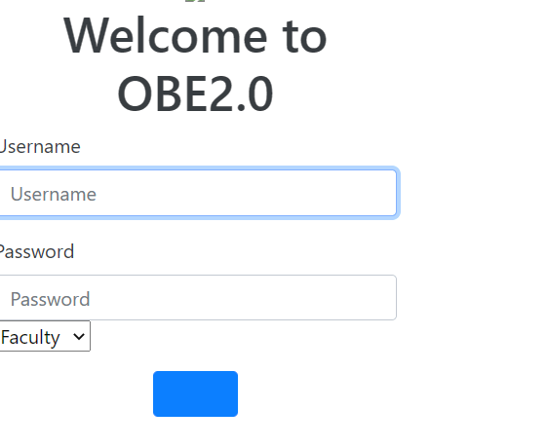

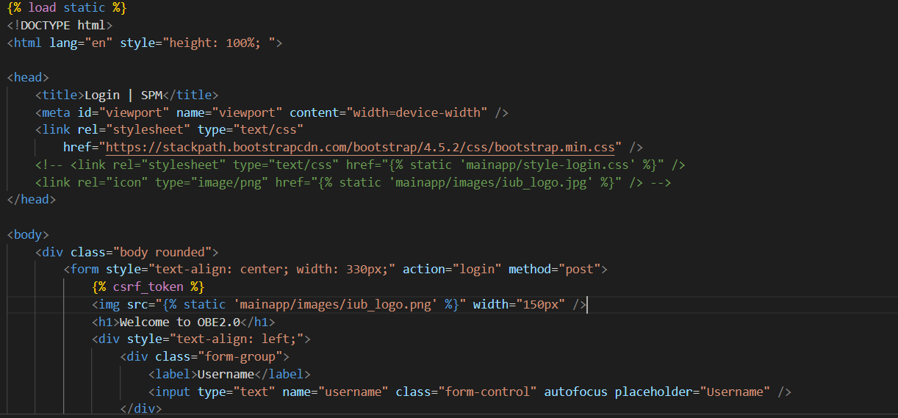

### 

### DASHBOARD

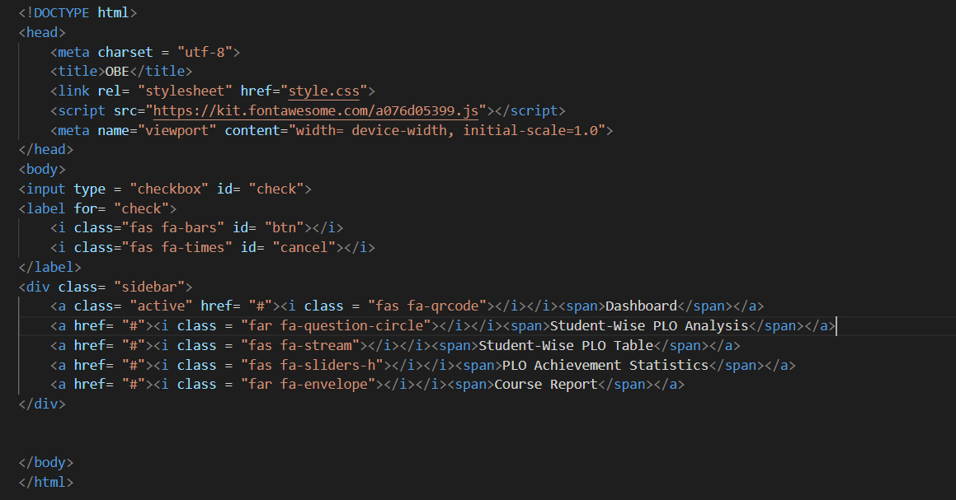

**The Question Bank**

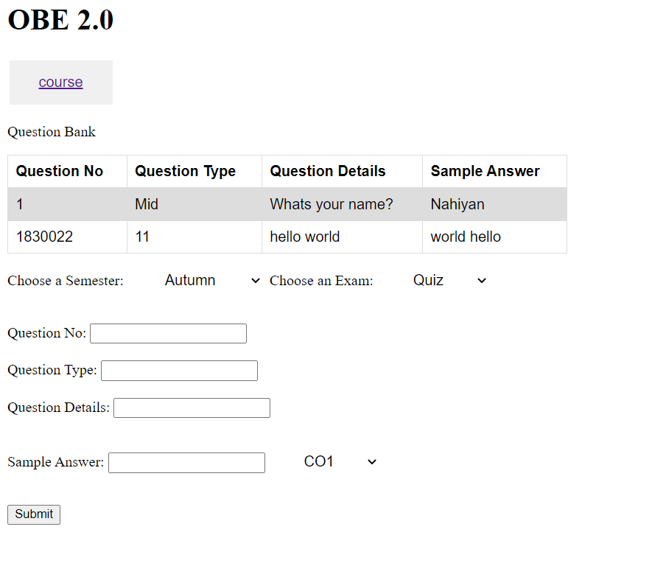

### <!DOCTYPE html>

### <html>

### <head>

### <style>

### select {

### border: none;

### color: black;

### padding: 15px 32px;

### text-align: center;

### text-decoration: black;

### display: inline-block;

### font-size: 16px;

### margin: 4px 2px;

### cursor: pointer;

### }

### button {

### border: none;

### color: white;

### padding: 15px 32px;

### text-align: center;

### text-decoration: none;

### display: inline-block;

### font-size: 16px;

### margin: 4px 2px;

### cursor: pointer;

### }

### table {

### font-family: arial, sans-serif;

### border-collapse: collapse;

### width: 40%;

### }

### td,

### th {

### border: 1px solid #dddddd;

### text-align: left;

### padding: 8px;

### }

### tr:nth-child(even) {

### background-color: #dddddd;

### }

### </style>

### </head>

### <body>

### <h1>OBE 2.0</h1>

### <button><ahref="/course">course</a></button>

### <p>Question Bank</p>

### <table>

### <tr>

### <th>Question No </th>

### <th>Question Type</th>

### <th>Question Details</th>

### <th>Sample Answer</th>

### </tr>

### {% foriinrow1 %}

### <tr>

### {% forjini %}

### <td>{{ j }}</td>

### {% endfor %}

### </tr>

### {% endfor %}

### </table>

### <formaction="question"method="post">

### {% csrf_token %}

### <labelfor="semester">Choose a Semester:</label>

### <selectname="semester"id="semester">

### <optionvalue="autumn">Autumn</option>

### <optionvalue="spring">Spring</option>

### <optionvalue="summer">Summer</option>

### </select>

### <labelfor="exam">Choose an Exam:</label>

### <selectname="exam"id="exam">

### <optionvalue="quiz">Quiz</option>

### <optionvalue="mid">Mid</option>

### <optionvalue="final">Final</option>

### </select>

### <br /><br />

### <labelfor="question_no">Question No:</label>

### <inputtype="text"id="question_no"name="question_no" />

### <br /><br />

### <labelfor="question_type">Question Type:</label>

### <inputtype="text"id="question_type"name="question_type" />

### <br /><br />

### <labelfor="question_details">Question Details:</label>

### <inputtype="text"id="question_details"name="question_details" />

### <br /><br />

### <labelfor="sample_answer">Sample Answer:</label>

### <inputtype="text"id="sample_answer"name="sample_answer" />

### <selectname="co"id="co">

### <optionvalue="co1">CO1</option>

### <optionvalue="co2">CO2</option>

### <optionvalue="co3">CO3</option>

### </select>

### <br /><br />

### <inputtype="submit"value="Submit" />

### </form>

### <p></p>

### </body>

### </html>

## **O RELATED SQL USED**

In the example given below, the creation of the database tables is represented:

--

-- Table structure for table `courseoutline`

--

CREATETABLE`courseoutline` (

`courseOutlineID`int(11) NOTNULL,

`courseID`varchar(10) NOTNULL,

`courseObj`varchar(255) DEFAULTNULL,

`courseDescription`textDEFAULTNULL,

`coursePolicy`textDEFAULTNULL,

`courseContent`textDEFAULTNULL,

`creditHour`int(11) DEFAULTNULL,

`courseValue`varchar(255) DEFAULTNULL,

`currentYear`int(11) DEFAULTNULL,

`lessonPlan`textDEFAULTNULL,

`materials`textDEFAULTNULL

) ENGINE=InnoDBDEFAULT CHARSET=utf8mb4 COLLATE=utf8mb4_unicode_ci;

-- -------------------------------------------------------

The following queries were written to meet certain requirements of the system:

**1.**

**SELECT * FROM question;**

This will allow the faculty to access details in the table.

**INSERT INTO question(quesID, quesType, quesDetail, sampleAns)**

**VALUES (‘1’,’easy’,’Write the smallest prime number in range 0-10’,’3’);**

The system will allow the faculty to add new questions to the question bank. The values entered are all examples.

**2.**

**SELECT * FROM assessment;**

This will allow the faculty to access details in the table.

**INSERT INTO assessment(assessmentID,bloomLevel,bloomCategory,marks)**

**VALUES ('1','1','remembering','10');**

The system will allow the faculty to add assessment for questions. The values entered are all examples.

**3.**

**SELECT \***

**FROM question**

**WHERE quesDetail LIKE '%verb%';**

This will search the quesDetail column which contains questions to search for a specific verb given and fetch the rows in question where the verb appears.

To make it easier to check for every verb, the following python code was made to create verb lists for every level, where the first index contains the Bloom level information:

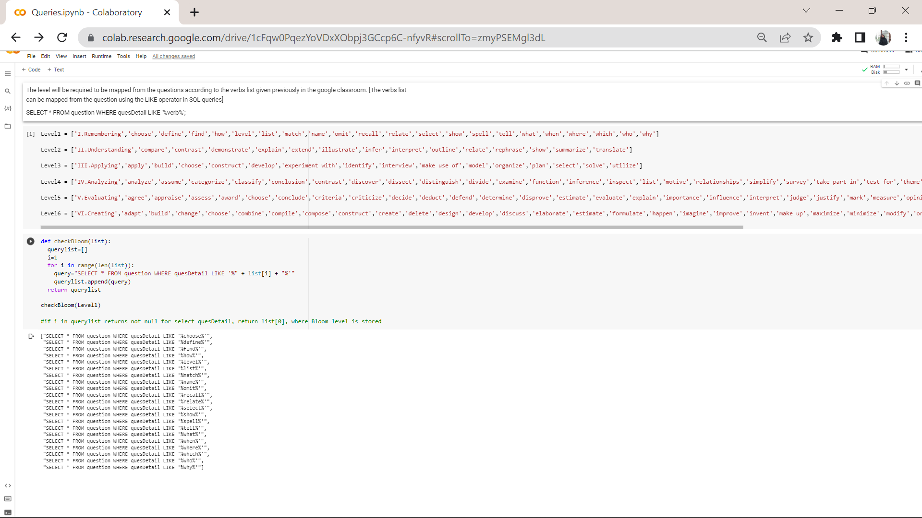

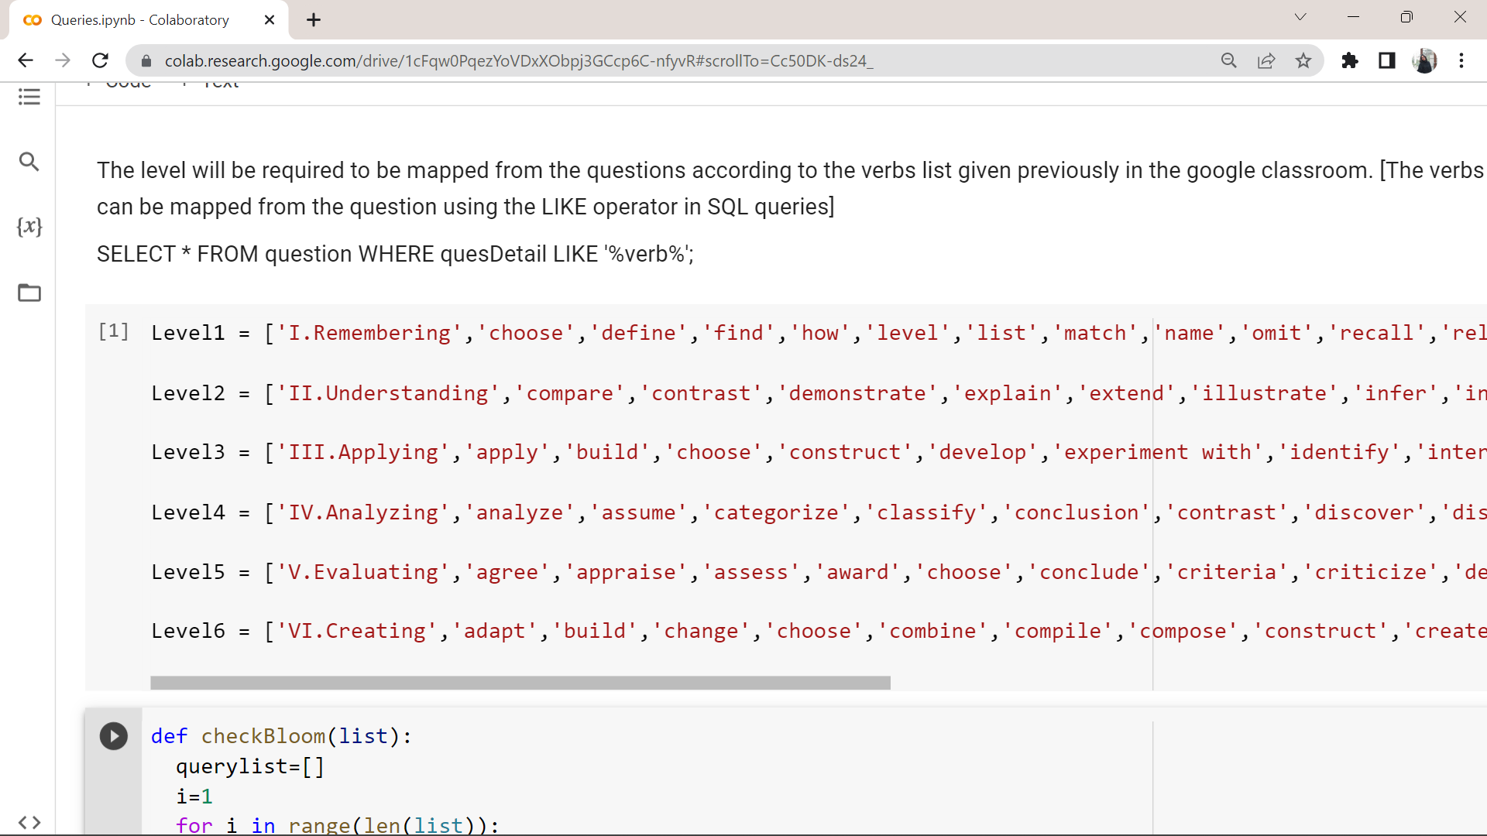

Then, the following function takes a list as parameter and generates queries for every verb in the list:

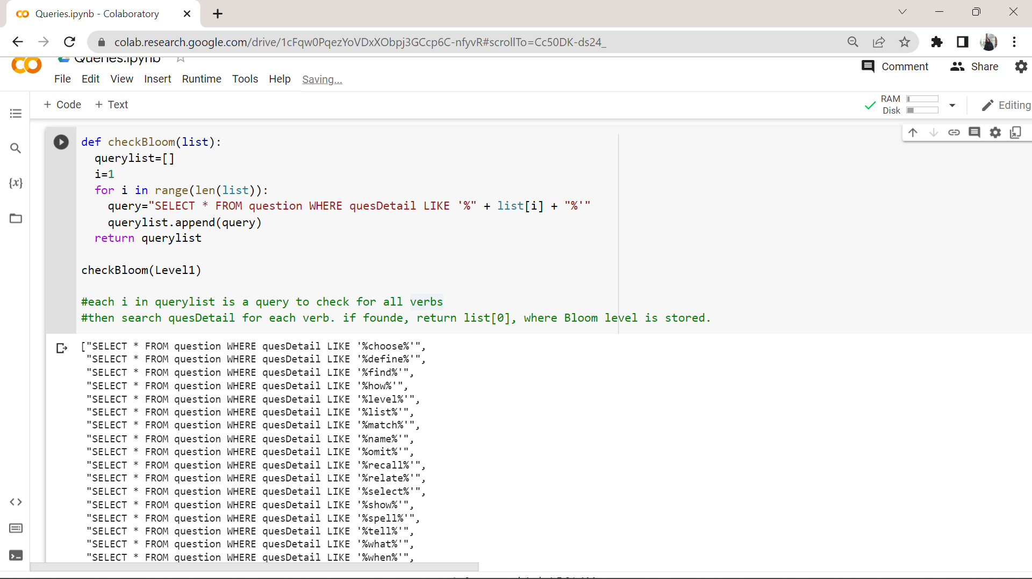

This function should be used for all 6 lists.

There is also pseudo code that describes a code that will search quesDetail column for every verb and if the verb is found, return list[0] to user, which contains the Bloom level information. So, for example, if ‘choose’ is found, the user should see a response ‘I.Remembering’ from the system.

**4.**

**SELECT * FROM courseoutline;**

This will allow the faculty to access details in the table.

**INSERT INTO courseoutline(courseOutlineID,courseID,courseObj,courseDescription,coursePolicy,courseContent,creditHour,courseValue,currentYear,lessonPlan,materials)**

**VALUES (‘1’,'CSE303','Learn DBMS','DBMS','No plagiarism','SQL','4','high','2022','plan','books');**

The system will allow faculty to add new course outlines to the course outline table in the database. The values entered are all examples.

**5.**

**INSERT INTO plo(ploID,ploLevel,ploName,ploDetails)**

**VALUES ('1','1','1stplo','details');**

Allows faculty users to insert PLO details into the database table. The values entered are all examples.

**6.**

**INSERT INTO co(coID,coLevel,coNumber,coDescription,ploID)**

**VALUES ('1','1','1','desc','1');**

Allows faculty users to insert CO details into the database table. The values entered are all examples.

CH-5 CONCLUSION

## **PROBLEM & SOLUTION**

## The teamhas tried their best to implement the best possible software within the limited time frame of the semester and were only able to do so given the sheets and information provided by the faculty members.

## However, our system lacks an automatic marking feature and multiple answers. It is not added to our system design.

## We believe we could have achieved more reliable and accurate results, presentations, and predictions if provided with more resources and data.

## **ADDITIONAL FEATURE & FUTURE DEVELOPMENT**

## In the future we would like to add the following features:

## 1. OBE2.0 will automatically mark the answer script.

## 2. A compiler will be added to identify the coding part easily.

## 3. We want to give higher authorities access so they can directly check the course syllabus and make changes if they want.

## 4. We want to add course material where faculty members can see how much time a student is spending on each course material.

## **CONCLUSION & RECOMMENDATIONS**

To conclude,the system is built to improve and make the process of grading more efficient by monitoring students. MysSQL workbench and XAMPP were used to create the database. Django was used to connect the backend and frontend.